In programming, we may come across problems where a process needs to be repeated over and over for a finite, but still unknown number of times to achieve a result. Well-known recursive functions include the factorial and the Fibonacci sequence. The first requires multiplying an integer and all previous positive integers together, although notably can be done more efficiently without a recursive function. The second takes the sum of the two previous numbers, which then requires knowing previous numbers, all the way to the base case. It is in this scenario that we see how recursion algorithms are used in programming: trees. A recursive algorithm can be used to search a tree for certain nodes, with the base case being the root.
The root of a tree has no parent, so any recursive search of a tree must end at the root, if ever considered. For all other nodes, a recursive algorithm will check the child nodes of a parent, then the next children, and so on. If a child node is a leaf, then the algorithm terminates running on that branch, as there are no children to further search, and it may continue on the next branch. An example of this would be searching for a file in explorer. If a user knows the specific name of a file or a folder, they can type search for it in the File Explorer. The system then goes through a tree of names, every internal node a folder, every leaf a file (or an empty folder). If the specific name isn’t found in a branch, then it is disregarded and the next branch is searched. For example, say I want to search for an application in File Explorer, but I only know the name, not where it’s located.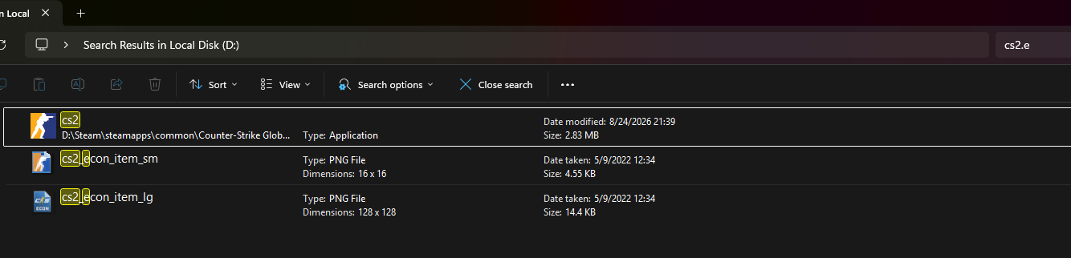
As seen here, I have a rough idea of the name, and the system finds three results that could match. It does not finish searching after one match, but finds all possible matches. Once the entire tree has been searched, the algorithm ends and presents all matches, if any.
In the real world, recursion algorithms are particularly important in finance. To predict profit or the value of an asset or stock, a recursion algorithm is used based on current and previous data to make a decision. The present value formula in finance shows the monetary value of a payment at some time t based on future payments being on a discount (Kobayashi para. 1). Furthermore, every person wants to maximize these values based on decisions they have to make with their money. The return on a bond is simple because it matures at a certain time, but it is complicated for evaluating stock futures (Kobayashi para. 5). A recursion algorithm can have an input of current data, such as the stock price at the moment, iterate through previous data, and output what the stock price might be at closing. For multiple stocks, there is an extra consideration of how much money should be spent on each stock to maximize profit margins, and even how long a position should be held before being sold. There is a base case of existing data, as the algorithm cannot check data older than what is provided. When reaching such a scenario, the algorithm should return a default value.
As in every recursive algorithm, there needs to be a base case that prevents the algorithm from running indefinitely. In the mathematical cases above, factorial ends with a base case of either 0 or 1, as negative numbers are not considered (outside of complex analysis), while the Fibonacci sequence starts with the zeroth and first numbers being 0 and 1. All recursions must have a base case, such as some default minimum or maximum values to stop at. For example, in the case of Knight Capital, its software continued to fill orders and gain positions, but were never reported (Speculative para. 16). Therefore, it was never checked if there was enough capital to fill these orders, and it kept running and running till the software was totally shut down (Speculative para. 17). The code simply executed on loop because the data was never changed, and there were no checks in place for this scenario. Perhaps establishing a base case that data has not changed compared to previous data could prevent execution.
Modern programming supports recursion through allowing a function to call itself. In the mathematical examples we gave at the beginning, factorial can call itself using the next smallest integer, all the way till it reaches the base case of 0 or 1. Fibonacci calls itself twice, creating a binary tree of function calls, before returning the sum. Python defaults to a maximum of 1000 calls before terminating to prevent a crash. Anything less than this will run (if no other errors), although not necessarily quickly. Otherwise, Python and C++ allow functions to be called internally, as long as a base case exists (GeeksforGeeks). Without a base case, an error will be returned after a limit, such as in the Python example. In the Knight case above, a recursion algorithm could be used, as long as there was a check on how much financial resources were available before filling positions. This is an implicit base case, as there is a minimum limit that stops the algorithm from running further. As long as such cases are present, a recursive algorithm can run properly.

Sources:
Kobayashi, T. (2026, January 7). The canonical autoregressive form: How geometric series convergence is hidden behind recursive equations | by Tomio Kobayashi | Medium. Medium. https://medium.com/@tomkob99_89317/mr-bellmans-journey-and-obsession-with-recursion-fe0574f63c9b
Badizadegan, N. (2023, November 22). The Knight Capital Disaster. Speculative Branches. https://specbranch.com/posts/knight-capital/
GeeksforGeeks. (2026, May 27). C++ recursion. https://www.geeksforgeeks.org/cpp/cpp-recursion/

